Application Instructions
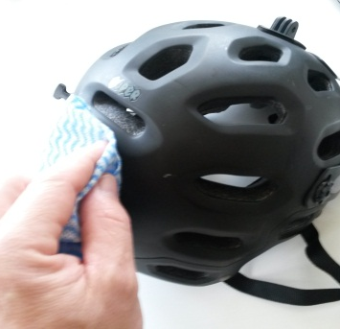 | Step 1  Clean the area thoroughly with rubbing alcohol or soap and water. Do not use window cleaning products that leave a residue behind that will prevent the sticker from adhering well.
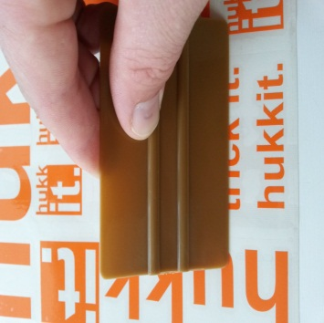 | Step 2  Prepare the sticker for application by firmly rubbing a squeegee or credit card across the clear transfer tape. This removes any air bubbles that may have formed and makes the sticker cling to the transfer tape.
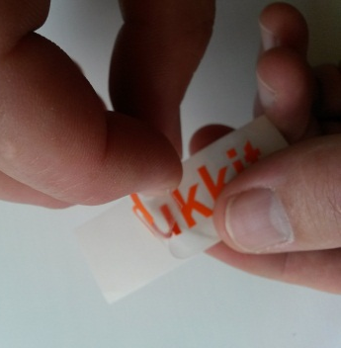 | Step 3  Cut out the image you want. Peel the white paper backing off the sticker. If the sticker clings to the backing, slowly replace the backing and repeat Step 2.
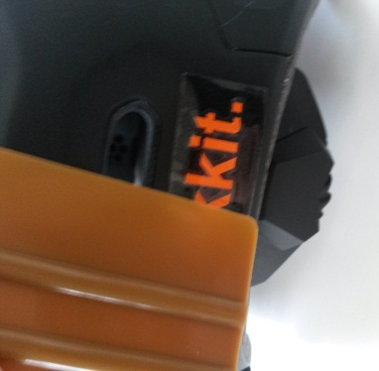 | Step 4  Slowly lower the sticker onto the surface and rub it in place firmly with a squeegee or credit card. Start at the top middle and the outer edges. Firmly rub the sticker in place to make sure there is no air trapped under the sticker.
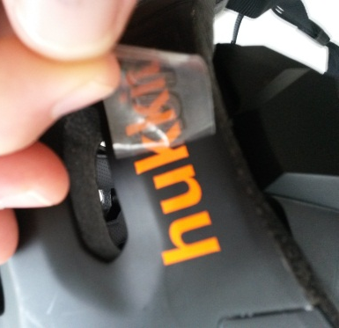 | Step 5  For the best results, wait 24 hours before moving to the next step. Slowly peel the clear transfer tape off at an angle. Be careful not to pull the sticker off the surface.  If the sticker pulls away from the surface repeat Step 4. Use a pin to poke any air bubbles in the centre and push the air out through the hole.
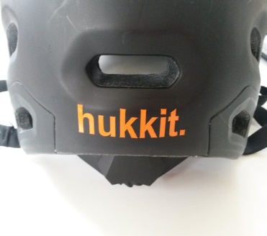 | For best results do not apply a sticker in extreme hot or cold temperatures

